11 - Man Overboard
Immediate emergency response procedures for man overboard situations ensuring rapid location, systematic recovery, and coordinated rescue operations.
Immediate Deck Actions
# | ACTION | VERB
08 | Visual Contact with Overboard Person | MAINTAINED
09 | Man Overboard Port or Starboard | SHOUTED
10 | Life Ring(s) | THROWN
11 | Guests and Crew | MUSTERED
12 | Head Count | EXECUTED
13 | Missing Person | IDENTIFIED

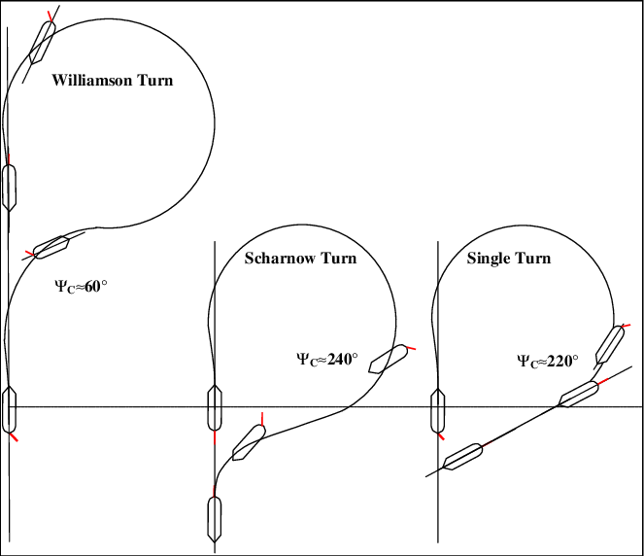
Search and Recovery Operations
# | ACTION | VERB
14 | Engine Room for Full Maneuverability | READY
15 | Lookouts with Binoculars | POSTED
16 | Recovery Plan for Persons from Water | READY
External Coordination and Support
# | ACTION | VERB
17 | Urgency to Vessels in Vicinity | BROADCAST
18 | MRCC and Nearby Vessels | ALERTED
19 | Immediate Medical Assistance | READY
20 | DPA and Company for Assistance | CONTACTED

